PARENT - TEACHER MEET ON 7TH JULY 2021

The Department of Social Work convened the Parent-Teachers' Meeting on July 7th 2021 on virtual platform.
The activities of the dept for the previous year were presented for parents' observation. The class teacher of both years of MSW had discussion with parent of respective each student and intimated them to ensure their children attend the class regularly. The grievances were also sought from parents. The meeting helped parents and teachers understand the genuinely and depth of grievances students face.
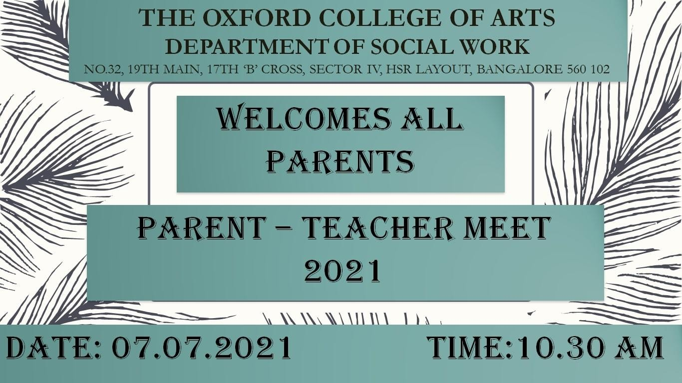
The meeting went successful as majority of the parents actively participated in the meeting.
